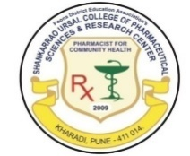
Pune Districts Education Associations
Shankarrao Ursal College of Pharmaceutical Sciences &
Research Centre, Kharadi, Pune-14.
_______________________________________________________

A Report on
THROWBALL
1st January – 5th January, 2026

The Throwball tournament was successfully conducted over multiple days with enthusiastic participation from various pharmacy programs. The inaugural match held on 1st January 2026 witnessed a competitive game between Third Year B. Pharm and First Year B. Pharm, in which Third Year B. Pharm emerged victorious.
This was followed by the second match on the same day between M. Pharm and Second Year B. Pharm, where Second Year B. Pharm secured a well-deserved win. On 2nd January 2026, Match 3 was played between D. Pharm and Final Year B. Pharm, and the Final Year B. Pharm team showcased excellent coordination and skill to claim the victory.
The semi-finals were also held on 2nd January 2026; in Semi-Final 1, Third Year B. Pharm defeated Second Year B. Pharm to advance to the final, while in Semi-Final 2, Second Year B. Pharm overcame Final Year B. Pharm to secure the second finalist position. The grand finale, held on 5th January 2026, was an exciting encounter between Third Year B. Pharm and Second Year B. Pharm. Demonstrating consistent performance throughout the tournament, the Third Year B. Pharm team emerged as the champions of the Throwball tournament and Ms. Pooja Babaladi from Second Year B.Pharm emerged as a Woman of the Tournament.
The event fostered sportsmanship, teamwork, and active participation among the students. The overall activity was conducted by Mrs. Trusha P. Shangrapawar, Ms. Dipali Chormale and Mrs. Ashwini Shinde.
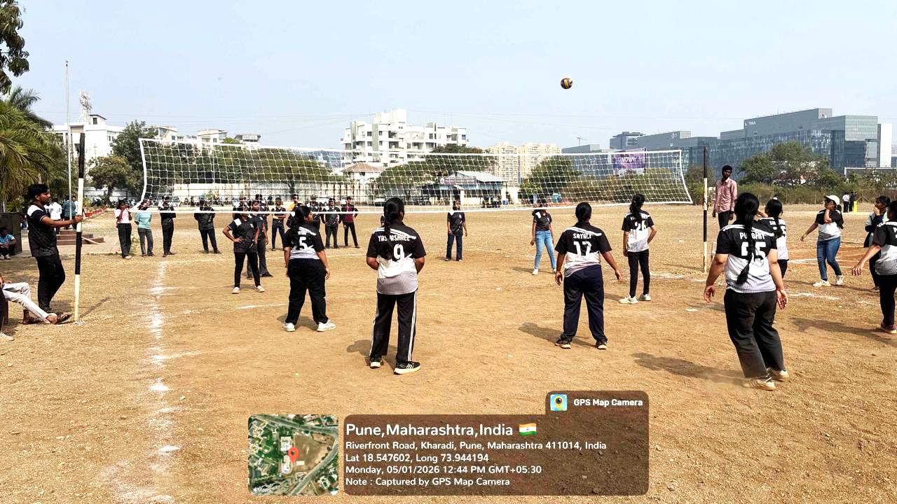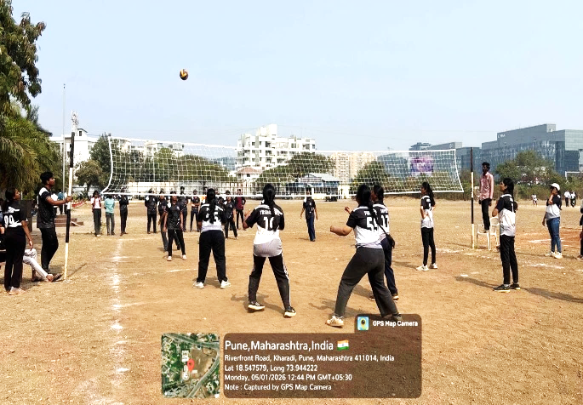
The grand finale at January 5 2026, between Third Year B. Pharm and Second Year B. Pharm
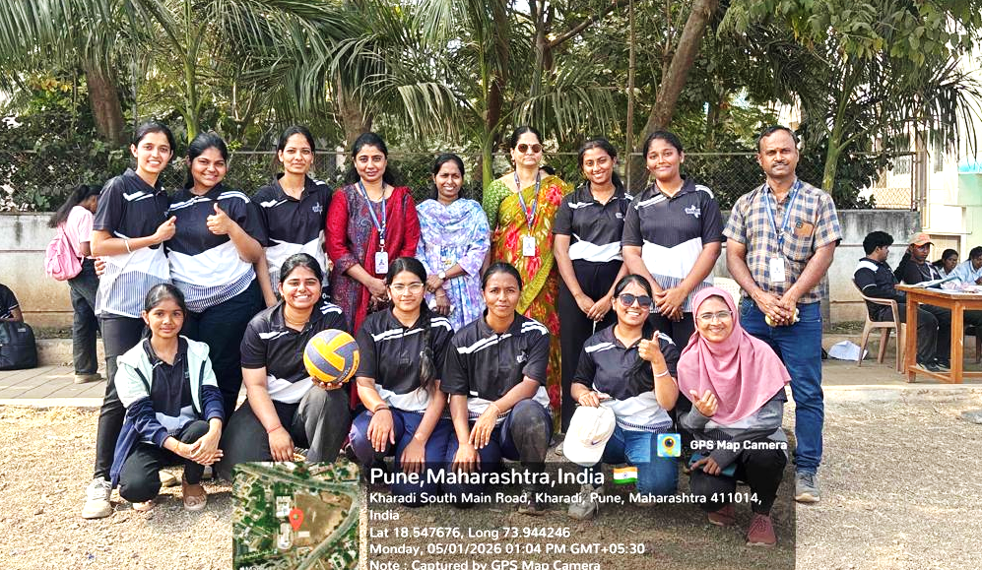
Winner Team Third Year B.Pharm
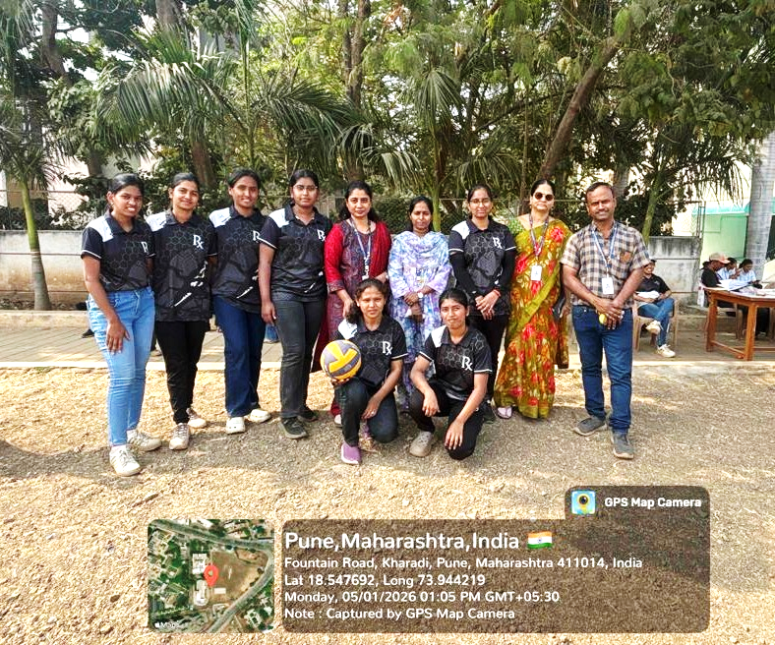
Runner –Up Team - Second Year B. Pharm
Mrs. Trusha P. Shangrapawar
Coordinator

